Introduction:
Why automation?
In order to overcome the drawbacks of manual testing and provides speed and accuracy to the existing testing process we choose automation.
When to start automation?
After the application is stable we can start automation.
Where to use automation?
Whenever something needs to be repeatedly tested again and again then we choose automation (there are so many reasons which we will learn slowly).
The Scope of automation in future?
As around 60% of the companies yet to implement automation testing so there is a good scope.
What is an automation tool?
It is an assistant of a test Engg which works on the instructions and information given by the test engg and finally shows the result.
How to learn any automated tool?
Generally we can learn in the following way
- How to give the instructions
- How to give information
- How to analyze the results.
Types of automation tools?
Black box testing tools are broadly divided into two types

Functional tool (qtp, selenium, win runner, rft, e.t.c)
Performance tool (load runner, jmeter, silk performer)

Selenium components:

Selenium IDE: it is set of programs + a user interface from where the user can interact with that set of programs.
Drawbacks:
- It works only with Firefox browser as it is an add-on of Firefox.
Selenium RC (remote control): it is a set of programs to perform automation testing, to interact with those programs we need to configure them in any user interface. Generally people use eclipse as it is a powerful editor for writing java programs.
Note: after selenium rc they have made selenium web driver as more powerful. Selenium web driver is providing more facilities for automation testing when compare to RC people started using web driver and slowly RC is getting deprecated.
Selenium web driver: it is a set of powerful programs to perform automation testing, to interact with those programs we need to configure them in any user interface.
Generally people use eclipse for configuring the web driver programming as it is a powerful editor for writing the java programs.
Selenium grid: it is a set of programs used for executing the tests parallel on multiple machines in order to increase the performance of execution.
How to configure selenium web driver?
To configure the selenium web driver we have to do the following
- Download & Install java (updated).
- Download selenium web driver (updated) from selenium website
- Get eclipse IDE for java EE developers 32 bit from internet we will get zip file then unzip it.
- Open eclipse folder we find this application then double click on it.

Starting with eclipse:
Navigation for creating a project:
  - Right click in the project explorer
  - Go to new select the option project
  - Select java project in the list then click on next
  - Specify the desired project name
  - Click on finish.
Navigation for creating a package:
  - Right click on src folder, go to new, select the option package
  - Specify the desired package name click on finish.
Navigation for creating a java file (class file):
- Right click on package , go to new
- Select the option class
- Specify the desired class name
- Select the check box
Public static void main
- Click on finish.
System.out.println () stmt: this stmt is used for printing something in the console.
Syntax: System.out.println(“string”);
Develop a java program for generating the following o/p in the console
Output:
package pack1;

public class boy {

public static int no_of_hands; public static int no_of_legs; //static members (variables)
public String name, colour;
public String ins_game, cls_of_stdy; //non static members (variables)
public static void breath() {
System.out.println("logic for breathing");
}
public static void sleep() {
System.out.println("logic for sleeping"); // static methods (functions)
}
public boy(String n,String c,String igame,String cos) {

name=n;
colour=c;
ins_game=igame; //parameterized constructor
cls_of_stdy=cos;
}

public void play() {
System.out.println(name+" playing "+ ins_game);
}
public void study() { //non static methods (functions)
System.out.println(name+" studying "+ cls_of_stdy);
}

Logic for breathing
Logic for sleeping
Mahesh
Suresh is white
Ramesh playing football
Suresh studying 2nd class
Ramesh studying 3rd class
Mahesh studying 4th class

public static void main(String[] args) {
no_of_hands=2;
boy. no_of_legs=2;
boy b1,b2,b3; //creating references as objects
b1=new boy("suresh","white","cricket","2nd class"); //allocating memory
b2=new boy("ramesh","mid white","football","3rd class");
b3=new boy("mahesh","pure white","hockey","4th class");
breath();
boy.sleep();
System.out.println(b3.name);
System.out.println(b1.name+" is "+b1.colour);
b3.play();
b1.study();
b2.study();
b3.study();
} }

} }

Object oriented programming language:
- Any object in this world belongs to some class
- Every object will have a set of properties and it can do some actions
- Properties are divided into two types
- Static properties
- Non static properties
- Actions are also dived into two types
- Static action
- Non static action
Static properties: if at all the properties are common to all the objects in that class then we call them as static properties.
Non Static properties: if at all the values of properties are changing form object to object in that class then we call them as non static properties.
Static actions (static functions): If at all some actions are commonly done by all the objects in that class then we will call them as static functions.
Non static actions (non static functions): If at all the objects are doing the actions which are changing from object to object in that class then we will call them as non static functions.
Note1: Static stub can be directly used in the program.
Note2: Non static stub can be accessed only through reference of the object.
Constructor: constructor is something which is used for constructing an object very easily
Syntax: [modifier] ClassName([datatype argument1, datatype argument2,…..]) {
Propertyname1= argument1;
Propertyname2= argument2; . . . . . }
E.g.: public boy(String n,String c,String igame,String cos) {

name=n;
colour=c;
ins_game=igame;
cls_of_stdy=cos;
}

Inheritance: It is a concept provided in java which is used for extending the parent class stub to the child class.
Note: one class can’t extend more than one classes at a time in java.
Note: one class can implement one or more interfaces at a time.
Overriding: if at all a function is existing in the parent class and the same function with same arguments we write in child class that concept is known as overriding.
Develop a java program to produce the following o/p using inheritance

Logic for father earning
Logic for father driving
Logic for son drive
Logic for son study
Logic for father earning
Logic for son drive
Logic for father earning

Father.java
package pack1;
public class father {
public void earn()
{
System.out.println("logic for father earning");
}
public void drive()
{
System.out.println("logic for father driving");
}
}

Son.java
package pack1;
public class son extends father {
public void drive() {

System.out.println("logic for son drive");
}
public void study() {
System.out.println("logic for son study");
} }
Test.java
package pack1;
public class test {
public static void main(String[] args) {
son s1=new son();
father f1=new father();
father fs=new son();
f1.earn();
f1.drive();
s1.drive();
s1.study();
f1.earn();
fs.drive();
fs.earn();
} }

Primitive data types: in java we have 8 primitive data types, they are as follows
Integer types
Byte: it is used to store an integer value up to 8 bits (-2^7 to 2^7-1).
byte b=18;
short: it is used to store an integer value up to 16 bits (-2^15 to 2^15-1).
Short s=345;
Int: it is used to store an integer value up to 32 bits (-2^31 to 2^31-1).
Int i=100;
Long: it is used to store an integer value up to 64 bits (-2^63 to 2^63-1).
long l=100000000;
Floating or decimals
Float : it is used to store a decimal value up to 32 bits.
Float f=34.45f;
doube : it is used to store a decimal value up to 64 bits.
double d=2345.45;
double d1=200;we can also store integer types in double data type
Conditional
Boolean: it is used for storing Boolean values like either TRUE or FALSE.
boolean b=true;
Character types
Char: it is used for storing a single character.
char c=’s’; it won’t allow to store more than one character.

String : it is predefined class in java which is used to store string in variables
String is not data type in java
String str=”hello india”;

Access modifier:
modifier | Within same package |  |  | Other package
modifier | Same class | Derived class | Other class | Derived class | Other class
Private | Allowed | Denied | Denied | Denied | Denied
Public | Allowed | Allowed | Allowed | Allowed | Allowed
Protected | Allowed | Allowed | Allowed | Allowed | Denied
default | Allowed | Allowed | Allowed | Denied | Denied
NOTE:
- default is not a key word in java.
- If we don’t mention any modifier then it treats it as default.
Interface:
Using Interface, We can create a contract or we can say set of rules for behavior of application. Interface is looks like class but It Is not class. When you implements that Interface In any class then all those Interface rules must be applied on that class.
It is a set of rules defined by us which has only declaration of functions, no body of the function and it will force us to override all the functions in the class which implements this interface.
Interface can be implemented with any class using implements keyword. There are set of rules to be followed for creating an Interface.
- Interface cannot hold instance fields/variables.
- Interface cannot hold static methods.
- You cannot instantiate/create object of an Interface.
- Any class can Implement Interface but cannot extend Interface.
- Can write body less methods Inside Interface.
- By default all the methods and variables of Interface are public so no need to provide access modifiers.

Syntax: [modifier] interface InterfaceName {
[Modifier] [Return type] methodName1();
[Modifier] [Return type] methodName2();
….. }
- Syntax : interface InterfaceName =new ClassName()
- E.g.: WebDriver wd= new FireFoxDriver();
- By declaring like this one can access all the WebDriver’s stuff as well as only overridden stuff from ClassName FireFoxDriver

Note:
- One can implement one or more interfaces at a time.
- We can’t create an object for an interface.
- We can create an object for a class which is implementing the interface and then give the reference of the interface.
Develop a java program which describes interface concept

Output phone.java

logic for mod1 call

logic for mod1 reject
package pack1;
public interface phone {
public void call();
public void reject();
}

model1.java
package pack1;
public class model1 implements phone {
public void call() {
System.out.println("logic for mod1 call");
}
public void reject() {
System.out.println("logic for mod1 reject");
}
public void dict() {
System.out.println("logic for dist ");
}
public static void main(String[] args) {
phone p1=new model1();
// model1 p1=new model1(); //1st un comment it den comment above stmt
p1.call();
p1.reject();
// p1.dict(); //2nd uncomment it otherwise error will come and press f11
} }

Overloading: If at all we have the same function more than once in a class with different arguments (may be no or type of arguments) then that concept is known as overloading.
Note:
- While calling any function we can call the required values.
- A function can return a value, if at all we want to return a value in the place of void we need to write data type of function and in the body we must write a return statement.
Develop a java program which describes overloading concept
Overloadingeg.java output
package pack1;
public class overloadingeg {
// public static int i,j;
public static int add(int x,int y){
return x+y; // method overloading
}
public static int add(int x,int y,int z){
return x+y+z; // method overloading
}
public static void main(String[] args) {
int i=add(10,20);
int j=add(20,30,40);
System.out.println("sum of 10 & 20:"+i);
System.out.println("sum of 20,30 & 40:"+j);
} }

sum of 10 & 20 is :30

sum of 20,30 & 40 is:90

Call by value & call by reference:
- Whenever we want to just use the values which are available in the object memory location without disturbing them, then we should use call by value function.
- Whenever we want to directly do the operations in the original object memory location then we should use call by reference function.
Note:
- Whenever we use call by value then it will store the values in new memory and do the operation, so it will not affect the original object memory location.
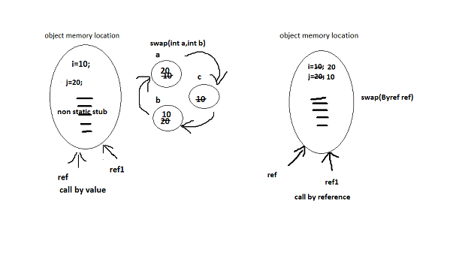

- Whenever we use call by reference then it will create new reference to the same object memory, so any operations performed using this new reference will affect the same original object memory location.

Develop a java program which describes call by value & call by reference concept
byvalref.java
package pack1;
public class byvalref {
public int i=10,j=20;
public void swap(int a,int b) {
int c=a;
b=a;
a=c;
}
public void swap(byvalref ref) {
int c=ref.i;
ref.i=ref.j;
ref.j=c;
}
public static void main(String[] args) {
byvalref ref1=new byvalref();
System.out.println("before swap i & j are:"+ref1.i+"---"+ref1.j);
ref1.swap(ref1.i,ref1.j);
System.out.println("after swaping i & j using call by value are:"+ref1.i+"---"+ref1.j);
ref1.swap(ref1);
System.out.println("after swaping i & j using call by ref are:"+ref1.i+"---"+ref1.j);
} }

Output

before swap i & j are:10---20
after swaping i & j using call by value are:10---20
after swaping i & j using call by ref are:20---10

Object class: It is a super class for every class we create in java
Whenever we create an object for any class, it will load non static info (stub) related to that class as well as the complete stub of object class also into the memory location created for that object, so using the same reference we can use the non static stub of that class as well as the complete stub of the object class in our program.
Note: object class is a special predefined class
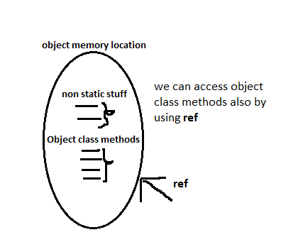

String class: It is a predefined class in java which contains some predefined functions to perform different operations on string. We can call all those functions in our programs by creating a reference to the String class.

Configuring selenium webdriver into eclipse:
- Open eclipse
- Create new project(java) then right click on the project
- Select the option properties
- Select Java Build Path
- Click on Libraries tab
- Click on Add External JARs…
- Select “selenium-java-2.24.1.jar, selenium-java-2.24.1-srcs.jar”
- Click on Add External JARs…
- Select all the jar files in the libs folder then
- Click on ok.
Note:
- install firebug add on to Firefox browser then ( if you are using Firefox as Ur browser)
- install firepath add on ( for finding xpath of an element)
- Above two things make us to identify elements very easily in a web page, almost like object spy in QTP.
Firebug: firebug is a add on of Firefox which is used for inspecting the web elements in the web application and knowing the information about them.
Firepath: firepath is a add on of Firefox which is used for specially showing the xpath of a web element.
Xpath: xpath is a unique locator of a web element in a webpage.
Navigation for firebug in the Firefox:
- Open Firefox browser
- Activate menu item tools
- Go to web developers then
- Go to firebug
- Click on open firebug
- To avoid above navigation press f12 we can directly open firebug.
Write a java program to demonstrate selenium webdriver
Login.java
package pack1;
import org.openqa.selenium.By;
import org.openqa.selenium.WebDriver;
import org.openqa.selenium.ie.InternetExplorerDriver;
public class Login { // login for warehouse executer project
public static void main(String[] args) {
WebDriver wd=new InternetExplorerDriver() wd.get("http://localhost/warehouse%20executer/login.aspx?ReturnUrl=%2fwarehouse+executer%2fAdmin%2fDefault.aspx");
wd.findElement(By.name("ctl00$ContentPlaceHolder1$txtUname")).sendKeys("admin");
wd.findElement(By.name("ctl00$ContentPlaceHolder1$txtPassword")).sendKeys("ADMIN");
wd.findElement(By.id("ctl00_ContentPlaceHolder1_btnLogin")).click();
} }

WebDriver: WebDriver is an interface developed by selenium people which is been implemented by so many classes like FirefoxDriver, InternetExplorerDriver, ChromeDriver, AndroidDriver, IPhoneDriver, SafariDriver etc.
At present people are using selenium webdriver for functional automation because it is so simple and more powerful than older selenium RC.
For e.g.: In selenium RC we need to start and stop the selenium server through program but no need to do it in selenium webdriver.
Operational overview of selenium: while giving the instructions to selenium we need to provide the information (properties of objects) to identify the object and also what operation to be performed on that object.
During execution selenium will work in the following way
- It will first identify the object using the information which is provided by us in the program.
- It will perform the action that is described in the instruction.
Object identification: In selenium we can make it identify the object in the web application with the help of properties like id, name, linkname, class, xpath, tagname etc.
Properties file: properties file used for storing some general information and can be reused in any java file (class) just by loading it. The following statements need to be used in that particular class

Properties p=new Properties();
FileInputStream i=new FileInputStream("path of the properties file");
p.load (i);
To retrieve any value from the Properties file we need to follow the below syntax
p.getProperty(“property name”);
Object Repository: in selenium there is no object repository concept but we will store all the objects information in the properties file and will treat it as object repository
- The same way how we load the properties file we can load the object repository.
- The same way how we use the properties file we can use the object repository.
Navigation for creating properties file:
- Right click on package
- Go to new then click on other or CRTL+N
- Click on General expand it then select File
- Click on next
- Specify the name then click finish.
Develop a java program to demonstrate the use of properties file (as an object repository) in selenium project.
package pack1;
import java.io.FileInputStream;
import java.util.Properties;
import org.openqa.selenium.By;
import org.openqa.selenium.WebDriver;
import org.openqa.selenium.ie.InternetExplorerDriver;
public class Login { // login for warehouse executer project
public static void main(String[] args) throws Exception {
WebDriver wd=new InternetExplorerDriver();
Properties p=new Properties();
FileInputStream i=new FileInputStream("C:\\Users\\BUJJI\\workspace\\webdriverproject\\src\\pack1\\objrep");
p.load(i);// uname pwd login all these are in objrep file
wd.get("http://localhost/warehouse%20executer/login.aspx?ReturnUrl=%2fwarehouse+executer%2fAdmin%2fDefault.aspx");
wd.findElement(By.name(p.getProperty("uname"))).sendKeys("admin");
wd.findElement(By.name(p.getProperty("pwd"))).sendKeys("ADMIN");
wd.findElement(By.id(p.getProperty("login"))).click();
} }

@@@ Java in detail @@@
VARIABLE: It is a name given to a memory location, which can hold a value and that can be changed any number of times in future if required.
Adv: Reusability & easy to maintain (future updations are easy) .
NOTE: always use meaningful names.
Syntax: Datatype variablename;
CONSTANT: It is a name given to a memory location, which can hold a value that can’t be changed in future.
Syntax: final Datatype constantname=value; if…. else
CONDITIONAL STATEMENTS :( decision making stmts)
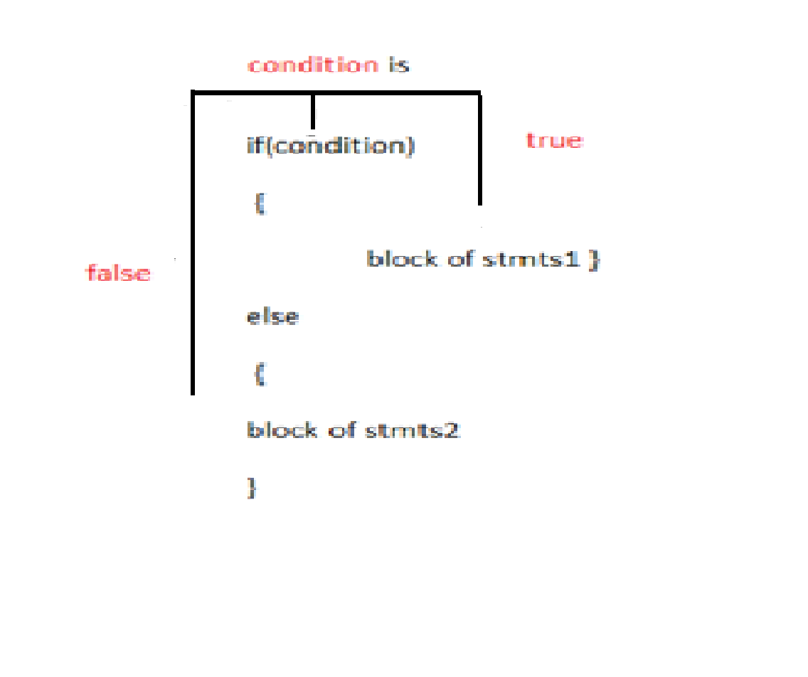
In java we have two types of conditional statements.
- If …else
- Switch… case
IF--- ELSE: whenever we want to execute one block of statements
among two blocks then we can use If..Else.
Syntax: if(condition) { block of stmts1 } else { block of stmts2 }
Note : condition is true then block of stmts1 will be executed

Switch…case: Whenever we want to execute a particular block of statements among many blocks then we will choose switch case statement.
Syntax: switch(choice) {
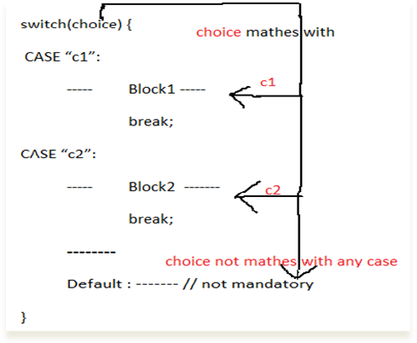
case “c1”:
block1
break;
case “c2”:
block 2
break;
-----------
Default: ------ // not mandatory
}
LOOPING STATEMENTS: Looping statements are used for executing a certain block of statements repeatedly and continuously for some number of times.
in java we have 3 types of looping statements
- for loop
- while loop
- do…while loop
for loop: whenever we clearly know how many no of times the block should be repeated then use for loop.
syntax : for(initiation ;condition ;improvement)
{
---------------- block of stmts
}
While loop: It is used for executing a block of statements repeatedly as long as the condition is being satisfied.
Syntax: while( condition)
{ ------- block of stmts
}
do---- while loop: It is used for executing a block of statements repeatedly as long as the condition is being satisfied, but first time execution will be done without checking the condition.
Syntax: do {
-------------block of stmts
} while(condition) ;
ARRAYS: Array is a special type of variable which can hold multiple values.
in java we have the following types of arrays
- single Dimensional array
- multi Dimensional array
- object array
- ArrayList class
- Hashtable class
Note: ArrayList class ,Hashtable class are predefined class of collection API in java.
For storing and retrieving values to and from array we will use index. Index starts with 0 and continues like 1.2.3……
Single Dimensional array
Syntax: datatype arrayname[] = new datatype[size];
Multi Dimensional array: to store more no of multiple values very easily we should use this array
Syntax: datatype arrayname[] [] = new datatype[rowsize][ columnsize];
Object array: it is used for storing multiple values of different datatypes
Syntax: Object arrayname []= new Object[size]; //to store single dimension
Object arrayname[] [] = new Object [rowsize] [ columnsize];//to store multi dimension
ArrayList class: it is used for simulating dynamically growing array.
Syntax: ArrayList<datatype> arrayname= new ArrayList<datatype>();
For retrieving values from this we will use index. Index starts with 0 and continues like 1.2.3……
To add data to this array we need to use the below syntax
Syntax: arrayname.add(data);
Note: here data is of same data type’s data by the time of declaration
To access(retrieve) data from this array we need to use the below syntax
Syntax: arrayname.get(indexno);
Hashtable class : is used for simulating dynamically growing array.
For storing and retrieving values to and from this we will use keys instead of Index
Syntax: Hashtable<datatype1, datatype2> arrayname= new Hashtable<datatype1, datatype2>();
datatype1 is for keys & datatype2 is for values and datatype1 ,datatype2 are datatype’s class name
To add data to this array we need to use the below syntax
Syntax: arrayname.put(data, data);
Note: here data is of same data type’s data by the time of declaration
To access(retrieve) data from this array we need to use the below syntax
Syntax: arrayname.get(key);

write a java program to demonstrate arrays : arrays.java
package pack1;
import java.util.ArrayList;
import java.util.Hashtable;
public class arrays {
public static void main(String[] args) {
String ch=" array list ";
switch(ch)
{

case "1d":
String[] s=new String[5];
s[0]="sree";
s[1]="kanth";
s[02]="sree kanth";
s[03]="kanth";
s[04]="sree";
for (int i=0;i<s.length;i++)
{
System.out.println(s[i]);
} break;
case "2d":
int a[][]=new int[5][5];
a[0][0]=0; a[1][1]=1; a[2][2]=2; a[3][3]=3; a[4][4]=4;

for (int i=0;i<a.length;i++)
{
for (int j=0;j<a.length;j++)
{
System.out.println(a[i][j]);
}
System.out.println("\n");
}
break;
case "object array" :
Object[] b=new Object[5];
b[0]="sree kanth";
b[1]="kola's age is";
b[2]=24;
b[3]="Btech % is";
b[4]=73.3f;
for (int i=0;i<b.length;i++)
{
System.out.println(b[i]);
} break;

case "array list" :
ArrayList<String> alist=new ArrayList<String>();
alist.add("sree");
alist.add("sree kanth");
alist.add("kola");
alist.add("Btech % is");
alist.add("73.3");
// alist.size(); returns size of array alist
for (int i=0;i<alist.size();i++)
{
System.out.println(alist.get(i)); } break;
case "hashtable" :
Hashtable<String,String > alist1=new Hashtable<String,String >();
alist1.put("fname","sree");
alist1.put("fullname","sree kanth"); alist1.put("lname","kola");
alist1.put("ug","Btech ");
alist1.put("percnt","73.3");
for (int i=0;i<alist1.size();i++)
{
System.out.println(alist1.get("fullname"));
} break;
default :System.out.println("invalid case selected");

} } }

String class: It is a predefined class in java which contains some predefined functions to perform different operations on string. We can call all those functions in our programs by creating a reference to the String class.
Predefined string functions in java useful for testing are as follows
package pack1;
public class stringmethods {
public static void main(String[] args) {
String s="i am writing program";
String s1="i am writing program";
System.out.println(s.length());
System.out.println(s.equals(s1));
int i=s.indexOf("program");
if(i!=-1)
System.out.println("string(program) is found ");
else
System.out.println("string(program) is not found ");
System.out.println(s.substring(2, 8));
String str[]=s.split(" ");
for(int j=0;j<str.length;j++)
{ System.out.println(str[j]);
} } }
Stringmethods.java
length(): finds the length of the string
equals(): compares two strings ,returns
true if both are matching else returns
false
subString(): selects a part of a string
indexOf():finds a word or a char in the
string then returns index of the string ,
if not find then returns -1
split(): splitting a string
program to demonstrate string class methods
Dynamic handling of file system :
Reading a file from memory
Physical memory
Fileread.java
It is a concept provided in java which is used for
Buffer
- - - -----
---- --- ---
- Creating a new file in a file system
- Writing data into a file
Some more files
--------
- Reading data from a file
f:\javafile.txt

br.readLine();
To do the same in java we have 5 predefined classes
--
- -
- File
f:\javafile.txt
br.close();
- FileReader
- BufferedReader
- FileWriter
FileReader fr=new FileReader("f:\\javafile.txt");
- BufferedWriter
BufferedReader br=new BufferedReader(fr);

Demonstration of file reading
package pack1;
import java.io.BufferedReader;
import java.io.FileReader;
import java.io.IOException;
public class fileread {
public static void main(String[] args) throws IOException {
FileReader fr=new FileReader("f:\\javafile.txt");
BufferedReader br=new BufferedReader(fr);
while(br.ready())
{
String s=br.readLine();
System.out.println(s);
}
br.close();
} }
Fileread.java

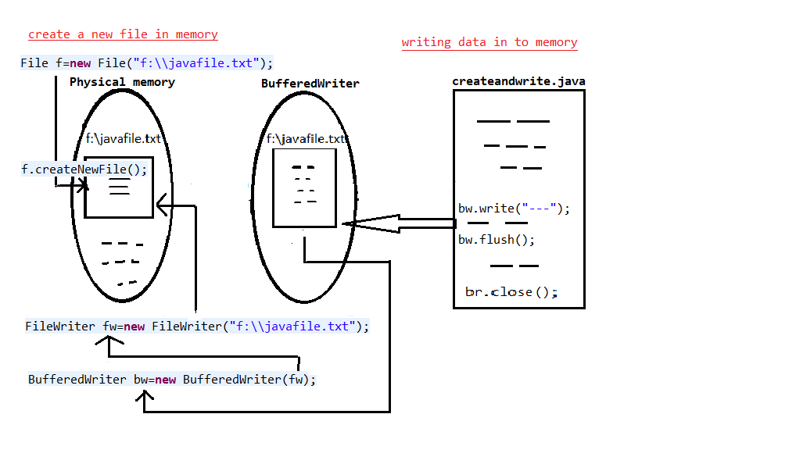

br.close() removes
BufferedWriter

package pack1;
import java.io.BufferedWriter;
import java.io.File;
import java.io.FileWriter;
import java.io.IOException;
public class filecreateandwrite {
public static void main(String[] args) throws IOException {
File f=new File("f:\\javafile.txt");
f.createNewFile(); // new file will be created
FileWriter fw=new FileWriter("f:\\javafile.txt");
BufferedWriter bw=new BufferedWriter(fw);
bw.write("hai go to f drive and check me "); bw.newLine();
bw.write(" hai !!! i am here..");
bw.flush();
bw.close();
} }

Demonstration of file creation & writing data into it
Operators in java:
Assignment operators: =
Concatenation operator: +
Arithmetic operators: + , - , * , /
Comparison operator: <,>,<=,>=,==,!=
Logical operator: &&,||,!
Ternary operator: ?:

Ternary operator: it is an alternative for if else.
Syntax: condition ? trueresult : falseresult ;

Eg: String av="sree",ev="sree";
System.out.println(ev.equals(av) ? "passed" :"failed");

Reflection API: it is a set of predefined classes, among them one of the classes which is useful for us is Method
Method class reference can hold any method (function) in the specified class using the same reference we can invoke that method (function).
Syntax1: String s="login"; // here login is a method having no arguments
Method m=methodreflectionapi.class.getMethod(s);
m.invoke(m);
syntax2: String s1="add"; // here add is a method having two arguments of type Integer
Method m1=methodreflectionapi.class.getMethod(s1,Integer.class,Integer.class);
m1.invoke(m1,10,20);
Note1: here if you use m.invoke(m); then it will call any method having no arguments, we can do it by just changing the String s value to another method name
Note2: here if you use m1.invoke(m1,”sree”,”kola”); then it will call any method having two string arguments, we can do it by just changing the String s value to another method name having two arguments.
Here methodreflectionapi is the class in which you have created and used to write Method
Note: from the above note1 and note2 what we need to understand is
- If at all a group of methods having same no of arguments then we can go for one reflectionapi’s Method class object for all the methods to avoid switch case. Using that object we can invoke any method as u like.
- If at all another group of methods having different no of arguments then we can go for that many no reflectionapi’s method class objects for avoiding switch case. Using those objects we can invoke corresponding method based on the no of parameters. So this is one back drop from this concept.
- It is working fine for static methods only.
Demonstration of Reflection API Method class
package pack1;
import java.lang.reflect.InvocationTargetException;
import java.lang.reflect.Method;
public class methodreflectionapi {
public static void login() {
System.out.println("logic for login");
}
public static void logout() {
System.out.println("logic for logout");
}
public static void login(String uname,String pwd) {
System.out.println("user name:"+uname+" \npassword:"+pwd);
}
public static void stradd(String a,String b) {
System.out.println("string is "+ a + b);
}
public static void add(int a,int b) {
System.out.println("sum is "+(a + b));
}
public void sub(int a,int b) {
System.out.println("diff is"+(a-b));
}
public static void main(String[] args) throws NoSuchMethodException, SecurityException, IllegalAccessException, IllegalArgumentException, InvocationTargetException {
String s="login"; // here login is name of the method
// String s="logout"; //Un comment it and comment above stmt
Method m=methodreflectionapi.class.getMethod(s);
m.invoke(m);
String s1="login";
// String s1="stradd"; //Un comment it and comment above stmt
Method m1=methodreflectionapi.class.getMethod(s1,String.class,String.class);
m1.invoke(m1,"sree","kola");
String s2="add";
// String s2="sub"; //Un comment it and comment above stmt
Method m2=methodreflectionapi.class.getMethod(s2,Integer.class,Integer.class);
m2.invoke(m2,10,20);
} }

SET: Set is an interface belongs to the collection API which is implemented by a class HashSet. It is similar to ArrayList it will be dynamically growing but will hold only unique values (even though you add duplicate values but it will take only one value in to the set).
Syntax: Set<datatype> setname=new HashSet<datatype>();

To add values in to a set we have the same add() method which is also available in the ArrayList.
Syntax: setname.add(data);
Note: here above data‘s data type must be set declaration’s data type
To retrieve values form a set here we don’t have get() method as like in ArrayList, so for this concept we have an interface Iterator in java.
Iterator: Iterator is an interface belongs to the collection API which is used to handle sets, list and so on. Simply Iterator reference acts like a pointer.
Syntax: Iterator<datatype> iteratorreference=setname.iterator();
Note: here Iterator’s data type & setname’s data type must be same.
Useful methods in Iterator interface for doing testing as follows
hasNext():Returns true if the iteration has more elements.
next():Returns the next element in the iteration.
Demonstration of set & Iterator interface with HashSet class
setdemo.java
package pack1;
import java.util.HashSet;
import java.util.Iterator;
import java.util.Set;
public class setdemo {
public static void main(String[] args) {
Set<String> s=new HashSet<String>();
s.add("a1");
s.add("a2");
s.add("a3");
System.out.println("set size is: "+s.size());
Iterator<String> itr=s.iterator();
while(itr.hasNext())
{
System.out.println(itr.next());
}
System.out.println("@@@@@@@@@");
s.add("a4");
System.out.println("set size is: "+s.size());
itr=s.iterator();
while(itr.hasNext())
{
System.out.println(itr.next());
}
} }

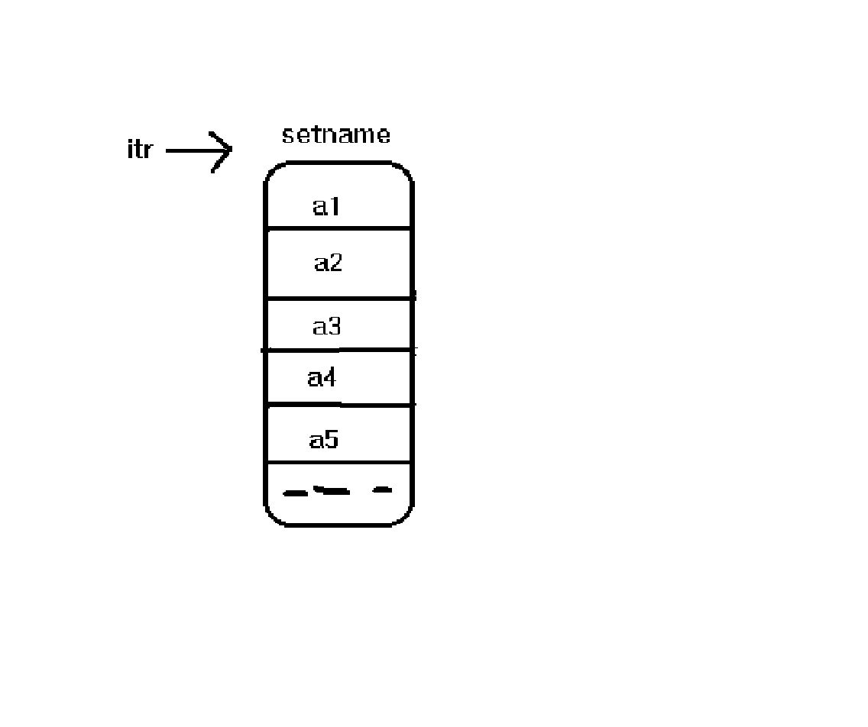

Note: once the Iterator is defined it points to one step ahead of 1st position in the set
Switching between windows: Generally selenium will focus on the 1st window, whenever the application moves to the next page or tab , selenium can’t automatically switch to that window so we need to make the selenium to switch to that latest window with the help of following syntax.
Webdriverreference.switchTo().window( "windowId" );
To get the window id we have a method in selenium is getWindowHandles();
Demonstration of switching between windows for hdfc.com
package pack1;
import java.util.Iterator;
import java.util.Set;
import org.openqa.selenium.By;
import org.openqa.selenium.WebDriver;
import org.openqa.selenium.firefox.FirefoxDriver;
public class hdfctabbedbrowse {
public static String freshwid;
public static void main(String[] args) {
WebDriver wd=new FirefoxDriver();
wd.get("http:hdfc.com");
Set<String> s=wd.getWindowHandles();
Iterator<String> itr=s.iterator();
while(itr.hasNext()) {
freshwid=itr.next();
} //use firebug to find xpath
wd.findElement(By.xpath("copy the customer care's xpath here")).click();
wd.findElement(By.xpath("copy the call us's xpath here")).click();
s=wd.getWindowHandles();
itr=s.iterator();
while(itr.hasNext()) {
freshwid=itr.next();
}
wd.switchTo().window(freshwid);
wd.findElement(By.xpath("copy the call us's xpath here")).click();
// we can avoid set & iterator concept by using below for loop
for(String handle:wd.getWindowHandles()) {
wd.switchTo().window(handle);
}
wd.findElement(By.xpath("copy the xpath here")).click();
} }

Exception handling in java :
While developing the java program there are some chances that the code which we have written can’t be executed then such type of situation is known as exception. Here we have two types of exceptions
- Called exception(checked exception)
- Unchecked exception(un called exception)
Called exception: while developing the code if java itself is giving the hint that there may be an exception then such type of exceptions is known as called exception.
Un Called exception: during the execution if java can’t do something then such type of exceptions are known as un called exception.
Try { } … catch { }: whenever we are developing a program if at all we have a doubt in any block of program which may lead to exception then it is better to keep that block in try and if exception occurs then what should happen we will write in catch block
Finally { }: the script present in the finally block will be executed at any cost irrespective of try block or catch execution is successful or not.
finally { System.out.println("!oops i(finally) executed ");}
Eg:
Throwable: it is a supper class of both Exception and Error class for catching an exception or error.
we can simply write “ Throwable t ” in catch block instead of writing exception or error
Eg:
catch (Throwable t) {
System.out.println(t.getMessage());

}

Throws: throws is used for automatically throwing the exception whenever we don’t want something specially to happen whenever exception occurs then instead of using try catch block it is better to use throws .here the main reason is throws class can handle the same exception any number of times in the program.
Throw: it is used for throwing an error explicitly by the program.
Used to throw user defined messages if error occurs
Selenium life cycle: Selenium life cycle contains 6 phases
- Test planning
- Generating the basic test
- Enhancing the test
- Debugging the test
- Executing the test
- Analyzing the results
Test planning: in this phase the automation test lead will do the following
- He will identify the areas to be automated
- He will analyze both positive and negative Flow of the application
- He will do the resource planning & scheduling
- He will prepare the automation test plan document with all the above analyzed information.
Generating the basic test: In this phase the automation test engg will generate both positive and negative Flow of the application.
Enhancing the test:
Checking with assertions: assertion is something like a checking statement which is used for checking whether the application is up to the exceptions or not
E.g.: finding an element, getting attribute value and comparing with expected value
package pack1;
import org.openqa.selenium.By;
import org.openqa.selenium.WebDriver;
import org.openqa.selenium.firefox.FirefoxDriver;
public class enhancingtestwithassertions {
public static void main(String[] args) {
WebDriver wd=new FirefoxDriver();
wd.get("http:cleartrip.com");
String expval="M",actval;
actval=wd.findElement(By.xpath("....")).getAttribute("value");
System.out.println((expval.equals(actval)?"passed":"failed"));
} }

Data driven testing: it is concept provided in selenium in order to implement retesting.
Retesting: It is type of testing in which one will perform testing on the same functionality again and again with deferent sets
of values, in order to confirm whether it is working fine or not.
Generally we store the multiple sets of data in a excel file. To read the data from the excel file apache people has developed “POI API” so we need to add the jar’s of POI API to our project how we add selenium jars and then can read the data in the following way.
Demonstration of reading data from excel file
package pack1;
//import java.io.BufferedReader;
import java.io.FileInputStream;
//import java.io.FileReader;
import java.io.IOException;
import java.io.InputStream;
import org.apache.poi.openxml4j.exceptions.InvalidFormatException;
import org.apache.poi.ss.usermodel.Cell;
import org.apache.poi.ss.usermodel.Row;
import org.apache.poi.ss.usermodel.Sheet;
import org.apache.poi.ss.usermodel.Workbook;
import org.apache.poi.ss.usermodel.WorkbookFactory;
public class readfromexcel {
public static void main(String[] args) throws InvalidFormatException, IOException {
InputStream fis= new FileInputStream("f:\\data.xlsx");
Workbook wb=WorkbookFactory.create(fis);
Sheet s=wb.getSheetAt(0);
for(int i=1;i<s.getLastRowNum();i++)
{ System.out.println("user names are: ");
Row r=s.getRow(i);
for(int j=0;j<r.getLastCellNum();j++)
{
Cell c=r.getCell(j);
System.out.println(c.getStringCellValue());
} } } }

getSheetIndex(): this method is used for getting the index of any sheet by providing the sheet name.
getLastRowNum():this method is used for getting the last row number in the sheet. Here count starts with 0
getLastCellNum():this method is used for getting the last no of cell in that row. Here count starts with 1
getSheetAt():this method is used for making selenium to focusing on the particular row based on the index.
Note: above mentioned are few methods but in poi api we have so many methods which are available and really useful for us. But you can also make or create your own methods which are not in poi api, then import it and can use it as you like.
e.g: in poi api we don’t have any method to get particular cell data based on the following requirement is getting value from desired location, desired sheet, desired row, and desired cell.
So the following example demonstrates us to create our own function based on the requirement
package pack1;
import java.io.FileInputStream;
import java.io.IOException;
import java.io.InputStream;
import java.util.concurrent.TimeUnit;
import org.apache.poi.openxml4j.exceptions.InvalidFormatException;
import org.apache.poi.ss.usermodel.Cell;
import org.apache.poi.ss.usermodel.Row;
import org.apache.poi.ss.usermodel.Sheet;
import org.apache.poi.ss.usermodel.Workbook;
import org.apache.poi.ss.usermodel.WorkbookFactory;
import org.openqa.selenium.By;
import org.openqa.selenium.WebDriver;
import org.openqa.selenium.firefox.FirefoxDriver;
public class readcelldatacustomizedclass {
public static String getCellValue(String sheetaddr,String sheetname,int rowno,int cellno) throws InvalidFormatException, IOException
{
InputStream fis=new FileInputStream(sheetaddr);
Workbook wb=WorkbookFactory.create(fis);
int s=wb.getSheetIndex(sheetname);
Sheet sht=wb.getSheetAt(s);
Row row=sht.getRow(rowno);
Cell cel=row.getCell(cellno);
fis.close();
return cel.getStringCellValue();
}
public static void main(String[] args) throws InvalidFormatException, IOException {

WebDriver wd=new FirefoxDriver();
wd.get("http://localhost/warehouse%20executer/");
wd.findElement(By.xpath("//*[@id='m1tlm3']")).click();
String uname=getCellValue("f:\\data.xlsx","sheet1",1,0);
System.out.println("user name entered is : "+uname);
wd.findElement(By.xpath("//*[@id='ctl00_ContentPlaceHolder1_txtUname']")).sendKeys( uname);
String pwd=getCellValue("f:\\data.xlsx","sheet1",1,1);
System.out.println("password entered is : "+pwd);
wd.findElement(By.xpath("//*[@id='ctl00_ContentPlaceHolder1_txtPassword']")).sendKeys(pwd);
wd.manage().timeouts().implicitlyWait(3, TimeUnit.SECONDS);
wd.findElement(By.xpath("//*[@id='ctl00_ContentPlaceHolder1_btnLogin']")).click();
wd.findElement(By.xpath("//*[@id='ctl00_lnkSignOut']")).click();
wd.close();
}
}

Note : below diagram demonstrates that what exactly happen while working with workbook

Program
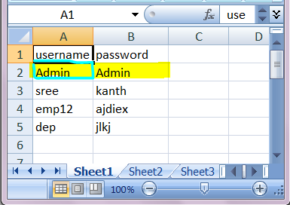
Work book
Physical memory
Sheet s=wb.getSheetAt(0);

Some more files
--------
Row r=s.getRow(i);

F:\\data.xlsx
Workbook wb=WorkbookFactory.create(fis);
Cell c=r.getCell(j);

InputStream fis= new FileInputStream("f:\\data.xlsx");

Synchronization: It is a process of matching the speeds of both the tool and the application in order to keep them in sync with each other to obtain proper testing results.
Here the main concept is making the selenium to wait till the main application allows it to perform the next operation. So it can be done in two ways
- By inserting Thread.sleep() statements.
- By inserting the implicitly wait() statements
Syntax: webdriverreference.manage().timeouts().implicitlyWait(time, TimeUnit);
e.g.: wd.manage().timeouts().implicitlyWait(30, TimeUnit.SECONDS);

Debugging the test: It is a process of executing the test in a user desired passion with some temporary breaks, in order to identify the Errors.
To do the same in eclipse has provided Break point feature and Step commands.
BREAKPOINT: It is used for breaking the execution temporarily.
STEP COMMANDS:
1. STEP into: It is used for executing a single step, if that step is a functional call step then it will make the pointer step into the function and breaks the execution at the first statement.
2. STEP return: this is option can used only whenever pointer is inside the function, it will execute all the remaining statements inside the function from the position of the pointer and breaks the execution after stepping out of the function.
3. STEP over: it is used for executing any step until it is finished, for example if it is a functional call statement it will execute all the statements inside the function and then breaks the execution.

EXECUTING THE TEST: In this phase one will execute the Test.
ANALYZING THE RESULT: In this phase one will analyze the Result.
@@@Advanced selenium@@@
Simulating the keyboard operations using selenium
We can make the selenium perform the keyboard related operations in the following way with the help of keys
Syntax: keys.KeyName
e.g.: keys.TAB, keys.ENTER.
Program to demonstrate keyboard operations
package pack1;
import org.openqa.selenium.By;
import org.openqa.selenium.Keys;
import org.openqa.selenium.WebDriver;
import org.openqa.selenium.firefox.FirefoxDriver;
public class warehouselogin {
public static void main(String[] args) throws InterruptedException {
WebDriver wd=new FirefoxDriver(); wd.get("http://localhost/warehouse%20executer/");
wd.findElement(By.xpath("//*[@id='m1tlm3']")).click();
wd.findElement(By.xpath("//*[@id='ctl00_ContentPlaceHolder1_txtUname']")).sendKeys("admin");
wd.findElement(By.xpath("//*[@id='ctl00_ContentPlaceHolder1_txtUname']")).sendKeys(Keys.TAB);
Thread.sleep(5000l);
wd.findElement(By.xpath("//*[@id='ctl00_ContentPlaceHolder1_txtPassword']")).sendKeys("ADMIN");
wd.findElement(By.xpath("//*[@id='ctl00_ContentPlaceHolder1_btnLogin']")).sendKeys(Keys.ENTER);
} }

Frameworks:
JUnit: it is software which provides some facilities through annotations which make the testing job easier as it is making some(testing) job more easy people generally call it as JUnit Framework.
Configuring JUnit into eclipse:
- Right click on project select Properties.
- Click on Java Build Path
- Click on Add Library
- Click on JUnit then click on Next
- From the drop down list box select JUnit4
- Click in finish.
Note: if the project is newly created then configure the selenium web driver also to your project, the process of configuring selenium is mentioned in the above pages.

Demonstration of JUnit framework

package junitdemo;
import org.junit.After;
import org.junit.AfterClass;
import org.junit.Before;
import org.junit.BeforeClass;
import org.junit.Test;
public class junitexample {
@BeforeClass //these are annotations availble in JUnit frame work
// this will be executed before entering into this class
public static void closeapplicationtest() {
System.out.println("application invoking logic is here");
}
/* @BeforeClass
public static void invokeapplicationtest() {
System.out.println("1111application invoking logic is here");
} // if same annotations tag is mentioned execution will be top to bottom
*/
@AfterClass // this will be executed after completing the class execution
public static void applicationclosetest() {
System.out.println("application closing logic is here");
}
@Before // this will be executed before test case execution
public void login()
{
System.out.println("logic for login is here");
}
@After // this will be executed after test case execution
public void logout()
{
System.out.println("logic for logout is here...");
}
@Test //test case
public void withdraw()
{
System.out.println("logic for withdraw is here....");
}
}

Note:
- We no need to have main() method in our class because JUnit is going to take care about it.
- It is old and famous framework having more no of annotations.
- Order of Execution is based on the annotations but not in the order in which we have written the code

TestNG(Next Generation): it is software which provides some facilities through annotations which make the testing job easier as it is making some(testing) job more easy people generally call it as TestNG Framework.
Navigation for downloading and installing TestNG into eclipse:
- Go to www.google.com
- Type install TestNG click on search
- Click on first URL then copy the url “for eclipse 3.4 and above”
- Open eclipse then click on help menu item
- Select the option Install New Software
- Paste the URL at Work With field then select the checkbox TestNG .
- Click on next….next
- Click on finish.
Note: after pasting the URL if you are not getting TestNG then follow the below steps
- Click on Add then in the Name field type TestNG and in the location field paste the URL then click on Ok.
- Now TestNG check box is available then click on next…next
- Click on finish.
Configuring the TestNG into eclipse:
- Right click on project select Properties.
- Click on Java Build Path
- Click on Add Library
- Click on TestNG then click on Next
- Click in finish.
Note: if the project is newly created then configure the selenium web driver also to your project, the process of configuring selenium is mentioned in the above pages.
Demonstration of TestNG framework
package TestNGdemo;
import org.testng.annotations.AfterClass;
import org.testng.annotations.AfterMethod;
import org.testng.annotations.BeforeClass;
import org.testng.annotations.BeforeMethod;
import org.testng.annotations.Test;
public class testngexample {
@BeforeClass //these are annotations availble in TestNG frame work
public void invokeapplicationtest() {
System.out.println("application invoking logic is here");
}
@AfterClass
public void closeapplicationtest() {
System.out.println("application closing logic is here");
}
@BeforeMethod
public void login() {
System.out.println("logic for login is here");
}
@AfterMethod
public void logout() {
System.out.println("logic for logout is here...");
}
@Test
public void withdraw() {
System.out.println("logic for withdraw is here....");
}
@Test //test case
public void balanceenqurytest() {
System.out.println("logic for balance enqury is here....");
} }

Note:
- We no need to have main() method in our class because TestNG is going to take care about it.
- It is new and famous framework having more no of annotations.
- Order of Execution is based on the annotations but not in the order in which we have written the code.
- More powerful reports will be generated compared to JUnit.
- JUnit and TestNG both are almost same difference is at annotations.
- In JUnit @BeforeClass and @AfterClass annotation’s methods must be static but in TestNG no need be static methods.
- In JUnit @Before and @After annotations are available but in TestNG we have @BeforeMethod and @AfterMethod
Ignoring or skipping test cases while executing:
In JUnit: we need to write @Ignore before @Test to skip that particular test.
E g.:
@Ignore
@Test //test case
public void balanceenqurytest() {
System.out.println("logic for balance enqury is here....");
}

In TestNG: to skip any test, in TestNG we need to write (enabled=false) along with @Test
E g.:
@Test(enabled=false)
public void withdraw() {
System.out.println("logic for withdraw is here....");
}

Data Driven Testing Using TestNG: it is a concept provided in automation in order to implement retesting, so using TestNG we can implement it in a very easy manner in the following way
- Create the @DataProvider annotation’s function which will read the data from the excel file directly into an array and returns that array to the test.
- The test will receive the data from the @DataProvider annotation function and executes the test many number of times depending up on the number of rows in the array
receiving data from @DataProvider function to a test
@Test(dataProvider="testdata")
public void loginbtnTest(String usrname,String pwd)
{
System.out.println("logic for testing loginbtn ”);
}

Note: here testdata is the method in which we have to write under @DataProvider annotation.
import TestNGdemo.getroworcolumnnoinsheet; this statement imports getrowcolumnnoinsheet.java file , in that class we have two methods(developed by me) columnscount() and rowscount() which accepts two parameters(path of the file, sheet name) of type string and returns no of columns and no of rows in a excel sheet(test data)respectively. Main use of writing those two functions is while creating dynamic two dimensional object array we can pass rowcount and columncount as parameters.

Creating @DataProvider annotation function “testdata”:
package TestNGdemo;
import java.io.FileInputStream;
import java.io.IOException;
import java.io.InputStream;
import TestNGdemo.getroworcolumnnoinsheet;
import org.apache.poi.openxml4j.exceptions.InvalidFormatException;
import org.apache.poi.ss.usermodel.Cell;
import org.apache.poi.ss.usermodel.Row;
import org.apache.poi.ss.usermodel.Sheet;
import org.apache.poi.ss.usermodel.Workbook;
import org.apache.poi.ss.usermodel.WorkbookFactory;
import org.testng.annotations.DataProvider;
public class datadrivenusingdataprovider {
public static int rcount,colcount;
@DataProvider
public static Object[][] testdata() throws InvalidFormatException, IOException{
String fromloc="f:\\data.xlsx",fromsheet="sheet1";Row r; Cell c;
InputStream fis=new FileInputStream(fromloc);
Workbook wb=WorkbookFactory.create(fis);
Sheet s=wb.getSheet(fromsheet);
rcount=getroworcolumnnoinsheet.rowscount(fromloc,fromsheet );
colcount=getroworcolumnnoinsheet.columnscount(fromloc,fromsheet);
Object[][] tstdata=new Object[rcount][colcount];
for(int i=0;i<=rcount;i++)
{
r=s.getRow(i+1);
for(int j=0;j<colcount;j++)
{
c=r.getCell(j);
System.out.println(c);
tstdata[i][j]=c.getStringCellValue();
} }
return tstdata;
}

package TestNGdemo;
import java.io.FileInputStream;
import java.io.IOException;
import java.io.InputStream;
import org.apache.poi.openxml4j.exceptions.InvalidFormatException;
import org.apache.poi.ss.usermodel.Row;
import org.apache.poi.ss.usermodel.Sheet;
import org.apache.poi.ss.usermodel.Workbook;
import org.apache.poi.ss.usermodel.WorkbookFactory;
public class getroworcolumnnoinsheet {
public static int columnscount(String sheetaddr,String sheetname) throws InvalidFormatException, IOException
{ InputStream fis=new FileInputStream(sheetaddr);
Workbook wb=WorkbookFactory.create(fis);
int s=wb.getSheetIndex(sheetname);
Sheet sht=wb.getSheetAt(s);
int rc=sht.getFirstRowNum();
Row r=sht.getRow(rc);
int c=r.getLastCellNum();
fis.close();
return c;
}
getroworcolumnnoinsheet.java

public static int rowscount(String sheetaddr,String sheetname) throws InvalidFormatException, IOException
{
InputStream fis=new FileInputStream(sheetaddr);
Workbook wb=WorkbookFactory.create(fis);
int s=wb.getSheetIndex(sheetname);
Sheet sht=wb.getSheetAt(s);
fis.close();
return sht.getLastRowNum();
}
}

Assertions: in selenium web driver there is a predefined class called Assert which provides so many predefined functions like assertequals(), assertTrue(),assertFalse() .. e.t.c.to do checking during the execution.
E.g.:
package junitdemo;
import junit.framework.Assert;
public class assertioneg {
public static void main(String[] args) {
String av="sree",ev1="sree",ev2="sree",ev3="sree143";
Assert.assertEquals("oops! not matched",av, ev1);
System.out.println("this will execute if av and ev are same:");
Assert.assertTrue("not allowed to execute below stmts", av.equals(ev2));
System.out.println("allows to execute below stmts if assertTrue succeded that is av and ev are same");
Assert.assertFalse("allows to execute below stmts if assertFalse succeded thatis av and ev are not same",av.equals(ev3));
}
}

@@@Selenium IDE @@@
Installing SIDE:
- Got to Google
- Type download selenium IDE
- Click on search
- Click on first link (download selenium)
- Click on version no (under selenium IDE section)
- Click on install
Navigation for accessing the selenium IDE in Firefox:
- Activate menu item tools
- Select option Selenium IDE or ctrl + Shift + S
Operational overview of recording:
During recording SIDE will do the following
- It will generate the commands for user actions on the application.
- It will store the information to identify that object in the form of target,
- If at all the operation is required to store a value then it will store that value.
Operation overview of running:
During running SIDE will do the following
- Using the target it will identify the object.
- Understanding the command then it will do the operation on that object
Inserting break point:
Break point is a feature provided in SIDE which is used for temporarily breaking the execution.
Navigation:
- Activate menu item Actions
- Select the option Toggle Breakpoint
Running scripts line by line (Debugging):
To do debugging in SIDE they have provided Step command which is used to execute single step and break the execution.
Inserting comments: comments are used for increasing the readability or understandability of a program.
Navigation:
- Activate menu item edit
- Select the option insert new comment
Inserting wait statement (Synchronization): whenever the application is taking some time to do some work and if at all we want the tool to wait till the application allows it to do the next operation then we need to insert wait statement. There are different predefined wait commands provided by the SIDE which we can use directly by typing them in the command.
Running the single line of script: To run a single line of script, do the following
- Select the line
- Activate menu item actions
- Select the option Execute This Command
Analyzing the results in log: once the execution is finished SIDE will show step by step results in log tab so that one can easily analyze the results.
Syntax and description of commands: here reference tab will provide the syntax and description of any command so by using this one can easily understand what is the purpose of any command and what are the arguments to be passed to that command.
Target: it is something which is used for identifying the object in the application it may be xpath or id or name... e.t.c.
In SIDE it will show the statements in two views
- Table view
- Source view
Table view: it shows the statements in a GUI which is further divided in to 3 parts
- Command
- Target
- Value
Source view: it shows the same statements in html format.
In this view <tr> tag indicates one row of the table (one statement) and <td> tag indicates one cell of the table
In SIDE every table row (<tr>) contains 3 cells (<td>)
E.g.:
<tr>
<td>open</td>
<td>/warehouse%20executer/login.aspx?ReturnUrl=%2fwarehouse+executer%2fAdmin%2fDefault.aspx</td>
<td></td>
</tr>

Note: generally SIDE is not encouraged in the companies because it works only with Firefox and also not so powerful like eclipse.
@@@Advanced Selenium@@@
Simulating front and back buttons of the browser:
We can make the web driver click on front and back buttons of the browser with the help of navigate().back() and navigate.forward() methods.
To use front and back we must open the page with the help of navigate() method instead of using get() method.
package advancedwebdriver;
import org.openqa.selenium.By;
import org.openqa.selenium.WebDriver;
import org.openqa.selenium.firefox.FirefoxDriver;
public class forntandbackbuttonsimulation {
public static void main(String[] args) throws InterruptedException {
WebDriver wd=new FirefoxDriver();
wd.navigate().to(" /");
wd.findElement(By.xpath("//*[@id='m1tlm3']")).click();
wd.navigate().back();
Thread.sleep(5000l);
wd.navigate().forward();
wd.findElement(By.xpath("//*[@id='ctl00_ContentPlaceHolder1_txtUname']")).sendKeys("admin");
wd.findElement(By.xpath("//*[@id='ctl00_ContentPlaceHolder1_txtPassword']")).sendKeys("ADMIN");
wd.findElement(By.xpath("//*[@id='ctl00_ContentPlaceHolder1_btnLogin']")).click();
} }

e.g.:

Finding the coordinates of web element:
To find the coordinates of a web element in Selenium web driver we have Point class and getLocation() method is available to us so we can do it very easily in the following way.
e.g.:
Point p;
p=wd.findElement(By.xpath("//*[@id='ctl00_ContentPlaceHolder1_btnLogin']")).getLocation();
System.out.println("x coord of login is: "+p.x+"\ny coord of login is: "+p.y);

Event Listeners: Event Listener is a concept provided by web driver which is used for automatically doing some operations whenever some operation is performed (like clicking on some object, navigate forward, navigate back).
Procedure for creating listener and handling events:
- First create one Listener class
- Extend it to AbstractWebDriverEventListener class.
- Override the predefined functions of AbstractWebDriverEventListener class with your own body or logic
- Create a new class for testing the listener which is created by you.
- Create a web driver reference
- Create a EventFiringWebDriver reference and then pass the web driver reference in the EventFiringWebDriver constructor
- Create a reference for first created listener class here in this class
- Register the listener class reference to the EventFiringWebDriver reference
- Then go for your own tests and enhancements as you like.
The following example demonstrates us the concept of event Listener
package advancedwebdriver;
import org.openqa.selenium.WebDriver;
import org.openqa.selenium.WebElement;
import org.openqa.selenium.support.events.AbstractWebDriverEventListener;
public class mylistener extends AbstractWebDriverEventListener {
public void afterClickOn(WebElement element,WebDriver driver) {
System.out.println("click operation performed");
}
public void afterNavigateBack(WebDriver driver) {
System.out.println("you asked to navigate back");
}
public void beforeClickOn(WebElement element, WebDriver driver){
System.out.println("before clicking on ...");
}
}

mylistener.java

Note: one event listener class is enough to handle events. We can use any of the event handling methods and must override AbstractWebDriverEventListener class methods. We shouldn’t use user defined methods for handling events but if u want to use it(user defined functions) then you will go for your own logic.
- what we can do with webDriver class reference the same can do with EventFiringWebDriver class reference and also makes the listener class to listen the corresponding events registered with it.

package advancedwebdriver;
import org.openqa.selenium.By;
import org.openqa.selenium.WebDriver;
import org.openqa.selenium.firefox.FirefoxDriver;
import org.openqa.selenium.support.events.EventFiringWebDriver;
public class mytestlistener {
public static void main(String[] args) throws InterruptedException {
WebDriver wd=new FirefoxDriver();
EventFiringWebDriver efwd=new EventFiringWebDriver(wd);
mylistener l=new mylistener();
efwd.register(l);
efwd.navigate().to("http://localhost/warehouse%20executer/");
efwd.findElement(By.xpath("//*[@id='m1tlm3']")).click();
efwd.navigate().back();
efThread.sleep(5000l);
efwd.navigate().forward();
efwd.findElement(By.xpath("//*[@id='ctl00_ContentPlaceHolder1_txtUname']")).sendKeys("admin");
efwd.findElement(By.xpath("//*[@id='ctl00_ContentPlaceHolder1_txtPassword']")).sendKeys("ADMIN");
efwd.findElement(By.xpath("//*[@id='ctl00_ContentPlaceHolder1_btnLogin']")).click();
}
}

mytestlistener.java

Pop up or java script Alert messages handling: it one of the main concepts in which we are regularly facing while doing web application testing. To handle this, in selenium we have predefined class called Alert.
The following example demonstrates pop up (alert) handling
package advancedwebdriver;
import org.openqa.selenium.Alert;
import org.openqa.selenium.By;
import org.openqa.selenium.WebDriver;
import org.openqa.selenium.firefox.FirefoxDriver;
public class popuporalertmessageshandling {
public static void main(String[] args) {
WebDriver wd= new FirefoxDriver();
wd.navigate().to("http:rediff.com");
wd.findElement(By.xpath("sign in xpath is here")).click();
wd.findElement(By.xpath("go button's xpath is here")).click();
Alert a=wd.switchTo().alert();
a.accept();
}
}

Mouse movement using selenium web driver:
Procedure for creating mouse movement actions:
- create WebDriver reference, after that
- create EventFiringWebDriver reference and pass web driver reference to it
- create listener class reference (procedure mentioned above in the event handling section)
- register the listener with EventFiringWebDriver reference
- create EventFiringMouse reference , pass WebDriver reference and listener reference to its constructor
- create Locatable class reference then find the element in which you have to move mouse on it and store in Locatable reference
- create coordinates class reference then store the coordinates in this reference
The following example demonstrates mouse movement:
package advancedwebdriver;
import org.openqa.selenium.By;
import org.openqa.selenium.WebDriver;
import org.openqa.selenium.firefox.FirefoxDriver;
import org.openqa.selenium.interactions.internal.Coordinates;
import org.openqa.selenium.internal.Locatable;
import org.openqa.selenium.support.events.EventFiringWebDriver;
import org.openqa.selenium.support.events.internal.EventFiringMouse;
public class mousemovement {
public static void main(String[] args) throws InterruptedException {
WebDriver wd=new FirefoxDriver();
EventFiringWebDriver efwd=new EventFiringWebDriver(wd);
mylistener l=new mylistener();
efwd.register(l);
efwd.navigate().to("http://localhost/warehouse%20executer/");
EventFiringMouse efm=new EventFiringMouse(wd,l);
Locatable item ; item=(Locatable)efwd.findElement(By.xpath("//*[@id='aspnetForm']/center/table/tbody/tr[2]/td/table/tbody/tr/td[1]/img"));
Coordinates c=item.getCoordinates();
Thread.sleep(5000l);// for better understanding observe the scroll bar
efm.mouseMove(c);
}
}

Dynamic web table handling:
The following example demonstrates dynamic handling of web tables:
package advancedwebdriver;
import java.util.List;
import org.openqa.selenium.By;
import org.openqa.selenium.WebDriver;
import org.openqa.selenium.WebElement;
import org.openqa.selenium.firefox.FirefoxDriver;
import org.openqa.selenium.support.events.EventFiringWebDriver;
public class dynamicwetablehandling {
public static void main(String[] args) throws InterruptedException {
WebDriver wd=new FirefoxDriver();
EventFiringWebDriver efwd=new EventFiringWebDriver(wd);
efwd.navigate().to("http://localhost/warehouse%20executer/frmWareHouseData.aspx");
efwd.navigate().to("http://localhost/warehouse%20executer/");
efwd.findElement(By.xpath("//*[@id='m1tlm3']")).click();
efwd.findElement(By.xpath("//*[@id='ctl00_ContentPlaceHolder1_txtUname']")).sendKeys("admin");
efwd.findElement(By.xpath("//*[@id='ctl00_ContentPlaceHolder1_txtPassword']")).sendKeys("ADMIN");
efwd.findElement(By.xpath("//*[@id='ctl00_ContentPlaceHolder1_btnLogin']")).click();
efwd.findElement(By.xpath("//*[@id='ctl00_AdminMenun13']/table/tbody/tr/td/a")).click();
efwd.findElement(By.xpath("//*[@id='ctl00_AdminMenun37']/td/table/tbody/tr/td/a")).click();
WebElement table=efwd.findElement(By.xpath("//*[@id='ctl00_ContentPlaceHolder1_GridView1']/tbody"));

List<WebElement> rows=table.findElements(By.tagName("tr"));
for(int i=1;i<rows.size();i++)
{
List<WebElement> cells=rows.get(i).findElements(By.tagName("td"));
for(int j=0;j<cells.size();j++)
{
System.out.println(cells.get(j).getText());
}
}
} }

